A Sleepover at the Library
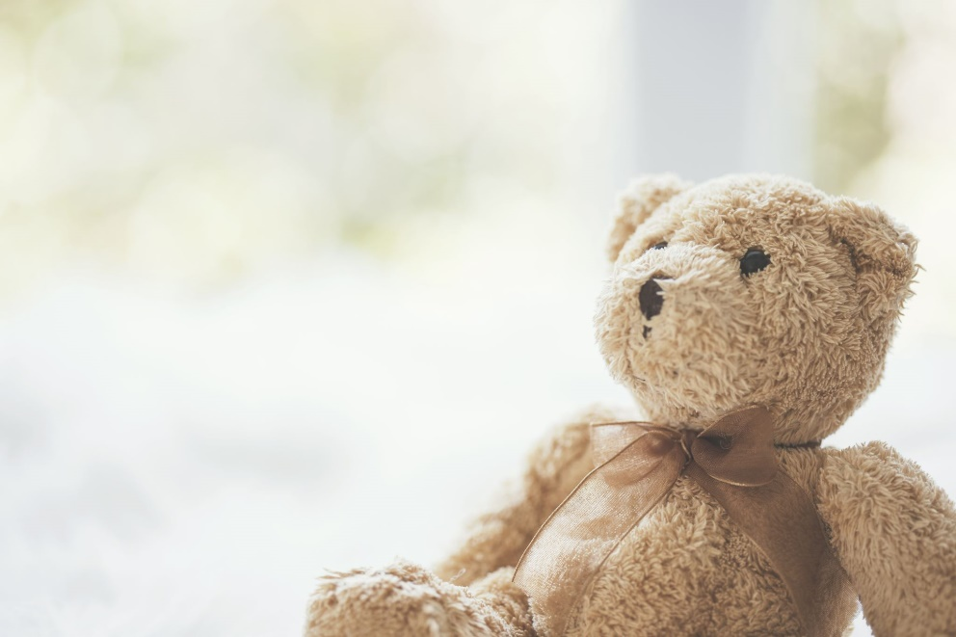

Library Name
Date

Library Logo

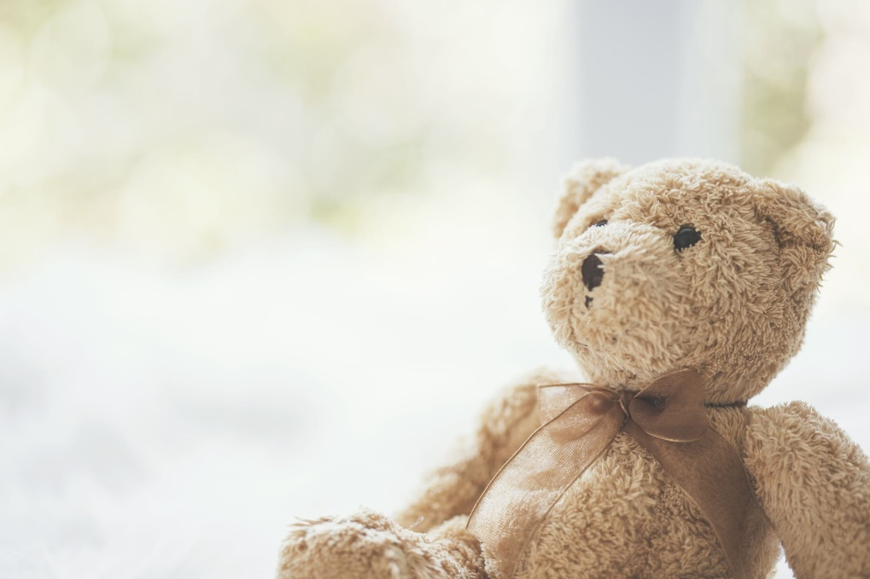

We’re having a sleepover at the library!
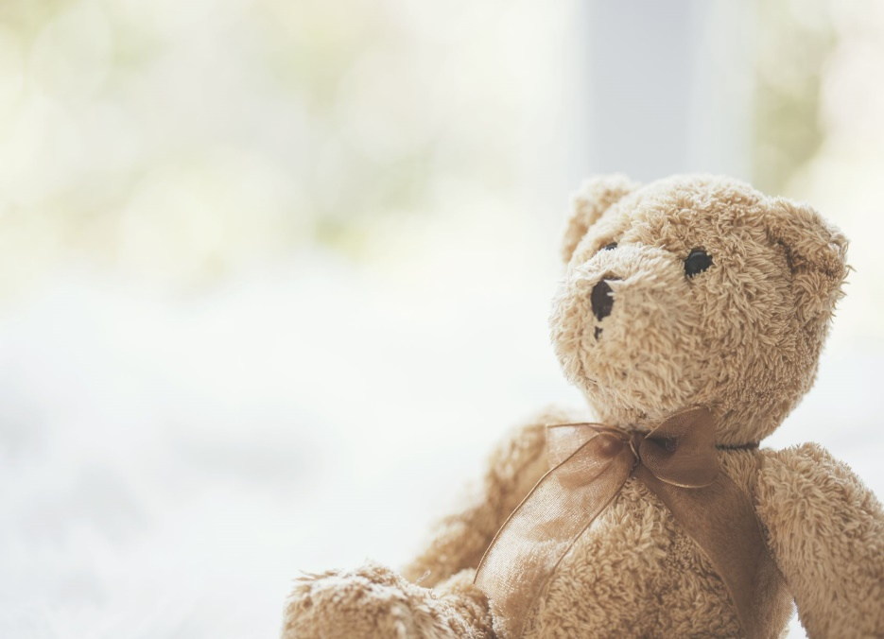

There are so many new friends to meet.

The librarian took us on a tour of the library. We even got to see the back room!

We played a fun game of hide and seek.
Can you find all of us?

After the game, we listened to stories. This book was my favorite!

Then it was bedtime. We all found a cozy place to sleep.

I had a great time at the sleepover, and made lots of new friends. I can’t wait for my next visit to the library!

